**AN ENGINEERING PROJECT REPORT**

**ON**

**ONLINE BUS RESERVATION SYSTEM**

**Submitted by:**

**Anil Ghimire 190101**

**Ayush Paudel 190102**

**Roshan Shrestha 190115**

**Dilip Karki 190145**

**Submitted to:**

**The Department of Information and Communication Technology**

**In partial fulfillment of requirement for the degree of**

**Bachelor of Engineering in Information Technology**



**Cosmos College of Management and Technology**

**(Affiliated to Pokhara University)**

**Tutepani, Lalitpur, Nepal**

**20th September 2022**

**AN ENGINEERING PROJECT REPORT**

**ON**

**ONLINE BUS RESERVATION SYSTEM**

**Submitted by:**

**Anil Ghimire 190101**

**Ayush Paudel 190102**

**Roshan Shrestha 190115**

**Dilip Karki 190145**

Under the Supervision of:

**Mr. Bibek Ropakheti**

**Submitted to:**

**The Department of Information and Communication Technology**

**In partial fulfillment of requirement for the degree of**

**Bachelor of Engineering in Information Technology**



**Cosmos College of Management and Technology**

**(Affiliated to Pokhara University)**

**Tutepani, Lalitpur, Nepal**

**20th September2022**

**COPYRIGHT**

The author has agreed that the Library, University of Pokhara, Cosmos College of Management

& Technology, may make this engineering project report freely available for inspection.

Moreover, the author has agreed that permission for extensive copying of this report for

scholarly purpose may be granted by the supervisor who supervised the work recorded here in or,

in their absence, by the college authority in which the project work was done. Copying or any

other use of this report for financial gain without approval of the college and author’s permission

is strictly prohibited.

Request for the permission to copy or to make and other use of the materials in this report in the

whole or in part should be addressed to:

Cosmos College of Management & Technology

©Copyright 2012

**CERTIFICATE**

The undersigned certify that they have read & recommended to the Department Information and Communications Technology, a Second-year project work entitled “**Online Bus Reservation System**” submitted by Anil Ghimire 190101, Ayush Paudel 190102, Roshan Shrestha 190115, Dilip Karki 190115 in partial fulfillment of the requirements for the degree of Bachelor of Engineering in Information Technology.

_____________________________

Mr. Bibek Ropakheti

(Project Supervisor)

Department of Information and Communication Technology

Cosmos College of Management and Technology

Name of External Examiner

(External Examiner)

Designation

Name of Institute

_____________________________

Mr. Bibek Ropakheti

Department of Information and Communications Technology

Cosmos College of Management and Technology

**ACKNOWLEDGEMENT**

We would like to express our sincere gratitude to Er. Dr. Pawan Kumar Bhattarai(Principal), Dr. Babu Ram Dawadi (Vice Principal), Er. Bibek Ropakheti (HOD) and Er. Abhishesh Dahal (DHOD) for their kind help and suggestion to complete this project. We would like to thank all our faculty teachers for always encouraging and motivating us to the highest peak and to provide us the opportunity to prepare the project.

We express our deep appreciation to Mr. **Bibek Ropakheti (**Supervisor) who always encouraged us and helped us at any time.

We would also thank our institution and faculty members without whom this project would have been a distant reality. We also extend heartfelt thanks to all our classmates and seniors for their support.

**ABSTRACT**

Online Bus Ticket Reservation System is a Web based application that works within a centralized network. The project presents a review on the bus transportation system, a facility which is used to reserve seats, cancellation of reservation and different types of route enquiries. The primary Features of the project are accuracy, flexibility and easy availability. It maintains all customer details, bus details, reservation details.

In addition, the project is developed in CSS, JavaScript as a frontend and PHP as backend by using visual studio code and we used MS WORD for documentation. For the database connection for the login form and review section we used PHP and MYSQL. The software achieved is capable of improving the customer hand and relationship management. Furthermore, the project also enables the vehicle owners for better marketing through online medium.

**TABLE OF CONTENT**

CHAPTER 1: INTRODUCTION……………………………………………………………11

       1.1 Background………………………………………………………………………….11

       1.2 Rationale……………………………………………………………………………..11

1.3 Problem of Statement ……………………………………………………………….12

       1.4 Objective…………………………………………………………………………….12

CHAPTER 2: LITERATURE REVIEW…………………………………………………….13

CHAPTER 3: REQUIREMENT ANALYSIS……………………………………………….14

* 1. Feasibility study………………………………………………………………………14

3.1.1 Technical Feasibility………………………………………………………………..14

3.1.2 Time Feasibility…………………………………………………………………….14

3.1.3Economic Feasibility………………………………………………………………..15

3.1.4Operational Feasibility……………………………………………………………...15

3.2 Functional and non-functional Requirements………………… …………………….15

3.2.1 Functional Requirements………………………………………………………….15

3.2.2 Non-Functional Requirements……………………………………………………….15

      3.3 Software and Hardware Requirement………………………………………………...16

3.3.1Hardware Requirement……………………………………………………………....16

3.3.2Software Requirement………………………………………………………………..16

      3.4 Tools and Equipment……………………………………………………………….....16

CHAPTER 4: METHODOLOGY…………………………………………………………....17

4.1. Incremental Design………………………………………………………………………17

4.2 Block Diagram...…………………………………………………………………………18

4.3 Use Case Design…………………………………………………………………….........19

4.4 Entity Relationship Diagram……………………………………………………………...20

CHAPTER 5: RESULT AND CONCLUSION. ….…………………………………………21

CHAPTER 6: LIMITATIONS AND FUTURE ENCHANCEMENTS**…**…...….…………...22

6.1 Limitations………………………………………………………………………………...22

6.2 Future Enhancement………………………………………………………………………22

CHAPTER7: CONCLUSION…………………………………………………………………27

CHAPTER8: REFERENCES………………………………………………………………….28

**LIST OF FIGURES**

1. Fig 4.1 Incremental Model
2. Fig:4.2 Block Diagram
3. Fig:4.3 Use case Diagram
4. Fig:4.4 ER Diagram
5. Snapshots:

Page 23: Home Page

Page 23: Dashboard

Page 24: Booked Details

Page 25: Customer Registration

Page 26: customer Login

Page 26: Admin login Panel

Page 27: Booking Status

**LIST OF ABBREVIATIONS:**

CSS: Cascading Style Sheet

GB: Gigabytes

GUI: Graphical User Interface

HTML: Hyper Text Markup Language

MYSQL: MY Structured Query Language

OS: Operating System

PHP: Hypertext Processor

UI: User Interface

**CHAPTER 1**

**INTRODUCTION**

* 1. **Background:**

The web-based bus ticket reservation system enables the customers to reserve their tickets through online medium easily and securely. The bus reservation system deals with the maintenance of records of each passenger who had reserved a seat for a journey.

This system will help the bus company to sell the tickets online. Unless like in the previous days, people have to walk into the travel agencies or ticket counters for buying tickets and check timings, this problem is overcome in this system. Using this system, the customer can check the schedule by logging into the website. When they login, they should give personal bio-data. After signing up for the new users, the customer can check the availability of bus, reserve their tickets, confirm as well as cancel their tickets. The design of this online system will be beneficial to the company because it has not existed before.

However, Online Bus Reservation System enables the customer to buy bus ticket, and ask for information online easily.

* 1. **Rationale:**

This project we’re conducting is the development of website that generally focuses on online bus reservation. This project is not just about the making the website but also focuses on helping travelers to book online ticket which while helps in saving time and effort by booking through internet services.

**1.3 Statements of the problem:**

Most of the bus companies in Nepal currently use manual system. Due to this cause, the company has several problems that negatively affect the reliability, performance, efficiency and effectiveness of day-to-day activities.

Manual system: The existing system is very time consuming and inefficient to the customer. This system is more prone to errors and sometimes the approach to various problems is unstructured.

Some of the major problems are: -

1. Inconsistent data and poor time management.
2. Requires stationary materials and also the system is slow.
3. Inefficient to their customer.
4. It takes a lot of time and cause many errors

To solve the above problem, the reservation system has helped the customer to enquire in order to get the latest update on schedule, the availability of ticket in a particular bus at particular date, helps him to reserve a ticket and cancel a reserved ticket.

**1.4** **Objectives:**

The main objectives of our project are: -

* + To develop online reservation system that will replace the manual ticketing system.
  + To enable customer to check the availability of the ticket online.
  + To enable customer to check the time departure and arrival for every bus through the system.
  + Admin user privileges in updating and canceling route and vehicle records.

**CHAPTER 2**

**LITERATURE REVIEW**

**BusSewa Nepal:**

Nepal’s first online Real-time bus ticket booking platformpowered by small heaven travel and tours Pvt. Ltd. BusSewa nepal came into existence with a vision of innovating business processes of Travel Operators in Nepal to provide quality service to road passengers. BusSewa ensures the tickets booking accessible to passengers at transparent prices with no booking charges. Passengers can get the most accurate real time data of bus seat availability from among the list of operators**.**

**Hamro Bus.com:**

Hamrobus.com came into existence in 2068 B.S. in a vision to innovate the quality service to each customer. It is setup by a troop of industry professionals. We started with the objective of making bus tickets booking accessible to individuals at transparent prices backed by best seat guarantee and excellent customer service. It is not just an online travel agency but is an enabler of the bus travel industry in Nepal.

**TicketSewa:**

TicketSewa’s parent company is G-force Systems & Technologies, the fastest growing IT solution provider of Nepal with 10 years plus of international experience.

Ticket Sewa offers a complete web-based Bus Reservation System. It is an E-ticketing solution that helps the traveler to book tickets online and gets instant confirmation. It is developed for seamless online reservation, communication and payment solution and providing end-to-end software and other value-added solutions for the Bus Transport Industry by leveraging the latest technologies.

By Taking different online bus reservation websites as a reference, we are going to create bus route, login page, and available tickets details of different bus going to their respective routes.

**CHAPTER 3**

**REQUIREMENT ANALYSIS**

**3.1 The feasibility study:**

After doing the project Online Bus Reservation System, study and analyzing all the existing or required functionalities of the system, the next task is to do the feasibility study for the project. All projects are feasible-given unlimited resources and infinite time.

Feasibility study includes consideration of all the possible ways to provide a solution to the given problem. The proposed solution should satisfy all the user requirements and should be flexible enough so that future changes can be easily done based on the future incoming requirements.

The main objectives of the feasibility study are to determine whether the project would be feasible in terms of the following categories:

* Technical Feasibility
* Time Feasibility
* Economic Feasibility
* Operational Feasibility

3.1.1 Technical Feasibility Study

Since the proposed system doesn’t require much technical expertise, it can be accessed easily by the users. The present equipment technology assures technical guarantee of accuracy, and reliability. So, it is found that the hardware and software meet the needs of the system. So, it’s clear that the proposed project is technically feasible.

3.1.2 Time Feasibility study

We try to make this project timely feasible by working actively and cooperatively with all the developing team.

3.1.3 Economic Feasibility

Economic feasibility attempts to weigh the costs of developing and implementing a new system, against the benefits that would gather from having the new system in place. This feasibility studies gives the top management the economic justification for the new system. Since the project we will be doing is based on open-source software, it is economically feasible.

3.1.4 Operational Feasibility

Since our website is interactive and data-driven, the user needs to be only a bit familiar with the software system backed with graphical explanations that can easily be understood faster in time with usage.

**3.2 Functional and Non-Functional Requirements:**

3.2.1 Functional Requirements:

A functional requirement is a description of the service that the software must offer. It describes

a software system or its components. A function is nothing but inputs to the software system, its

behavior, and outputs. It can be a calculation, data manipulation, business process, user

interaction, or any other specific functionality which defines what function a system is likely to

perform. Functional requirements are also called functional specifications.

3.2.2 Non-Functional Requirements:

A non-functional requirement is a requirement that specifies criteria that can be used to judge the

operation of a system, rather than specific behaviors. The plan for implementing functional

requirements are detailed in the system design. The plan for implementing non-functional

requirements are detailed in the system architecture because they are usually architecturally

significant requirements.

Based on these, the non-functional requirements of the project are as follows:

● The system should be user-friendly.

● The system should be secure to use

**3.3 Software and Hardware Requirements:**

3.3.1 Software Requirements:

The following are the software requirements for our system:

* Front End: HTML, CSS
* Database: MySQL
* Back End: PHP

3.3.2 Hardware Requirements:

* Processor: Minimum 1GHZ, recommended 4GHZ
* RAM: Minimum 2GB
* Operating System: Windows 7 or later

**3.4 Tools and Environment:**

* Visual Studio Code: For coding and text editing.
* Web Browser (Google Chrome): For testing and displaying output.
* Database: MYSQL Server
* HTML: Markup language.
* CSS: Stylesheet language to style a markup language document.
* PHP: Server-side scripting language.
* JavaScript: Scripting Language

**CHAPTER 4**

**METHODOLOGY**

The methodology describes the procedures, tools, techniques that were employed to achieve the specific objectives of the bus reservation system for bus. For this project, we have used the Incremental Model of Software Process Model. This model combines linear sequential model with the iterative prototype model.

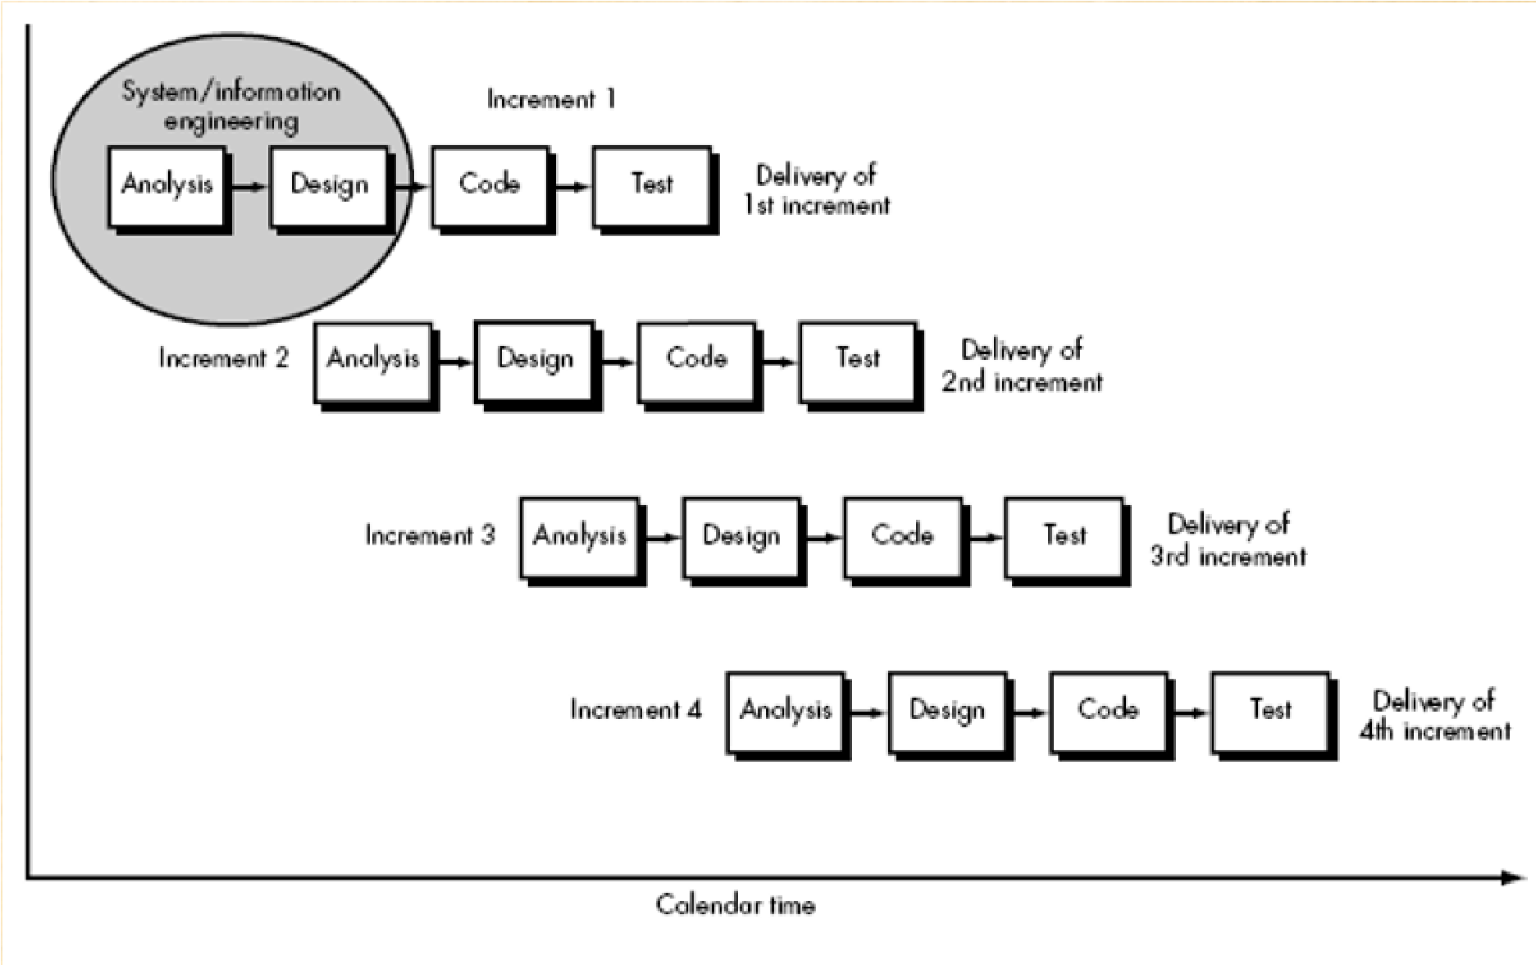

**4.1 INCREMENTAL MODEL**

Incremental model includes the following phases:

**• Analytic Phase:**

In this phase, the requirements of the software are analyzed which resulted in Software Requirement Specifications.

* **Design Phase:**

In this phase, analysis the SRS was translated into the system’s design. Context Diagram, Use-Case Diagram, ER Diagram and Class Diagram were developed.

* **Coding Phase:**

This phase involves the coding as per the design and formation of a working system at the end of the process.

* **Testing Phase:**

In this phase, the system was tested. With each testing, certain changes were made as per the suggestion. This was done in an incremental manner until a satisfactory system was made.

**4.2 BLOCK DIAGRAM:**

**Admin**

**Update**

**Online Bus reservation**

**Confirmation**

**Login Confirmation**

**Customer**/**Passenger**

**4.3 USE CASE DIAGRAM:**

**Bus availability Enquiry**

**Make Reservation**

**User**

**Cancel Reservation**

**Print Ticket**

**Admin**

**Login**

**Update Route**

**Update Payment**

**Update Bus**

**4.4 ENTITY RELATIONSHIP DIAGRAM:**

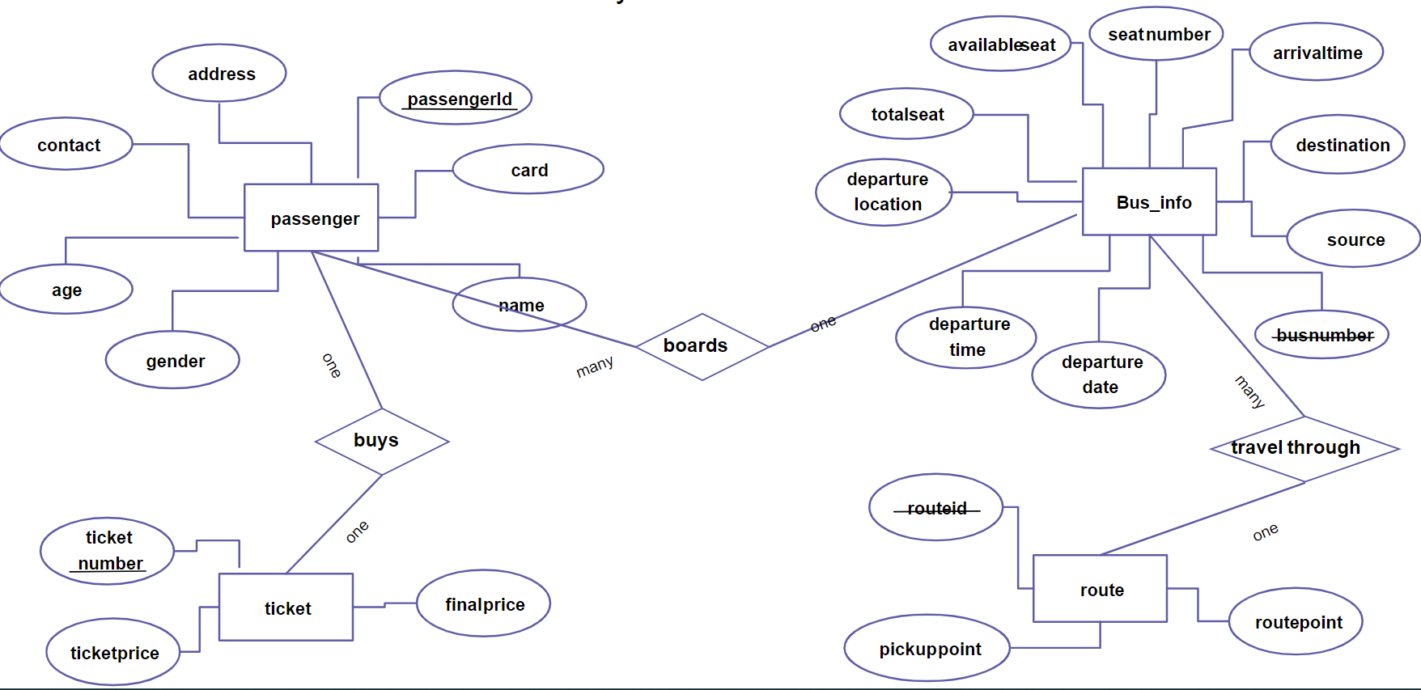

**CHAPTER 5**

**RESULT AND DISCUSSION**

The proposed bus reservation system was developed using Hypertext Markup Language (HTML), PHP Hypertext Preprocessor (PHP), Structure Query Language (SQL), Cascading Style Sheet (CSS), and JavaScript.

**Chapter 6**

**LIMITATIONS AND FUTURE ENCHANCEMENTS**

Although we have put our best efforts to make the software flexible, easy to operate but limitations cannot be ruled out even by us. This website we’ve created is only a basic framework to a practical website. Here, the functionalities are limited. This website can still be improved in many terms for the best.

**6.1 Limitations**

The following are the limitations of this system:

* Customers cannot find others Routes that are not included in our website.
* Customers cannot book the ticket itself.
* Online payment using credit cards/debit cards and other E-payment methods like Khalti, Esewa are not possible.

**6.2 Future Enhancements**

In a nutshell, it can be summarized that the future scope of the project circles around maintains information regarding:

* We will host the platform on online servers to make it accessible worldwide.
* Able to book the tickets of different routes all over the county.
* Making the website more secure.
* Introducing the online payment methods using credit/debit cards into the system.

The above-mentioned points are the enhancements which can be done to increase the applicability and usage of this project. Here we can maintain the records of Bus and Ticket. Also, as it can be seen that now-a-days the players are versatile, i.e., so there is a scope for introducing a method to maintain the Bus, Ticket, Booking, Customer, Bus Route.

We have left all the options open so that if there is any other future requirement in the system by the user for the enhancement of the system then it is possible to implement them.

**Some Snapshots:**

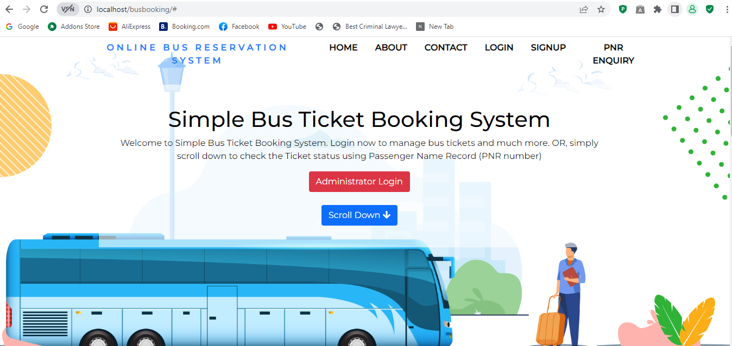

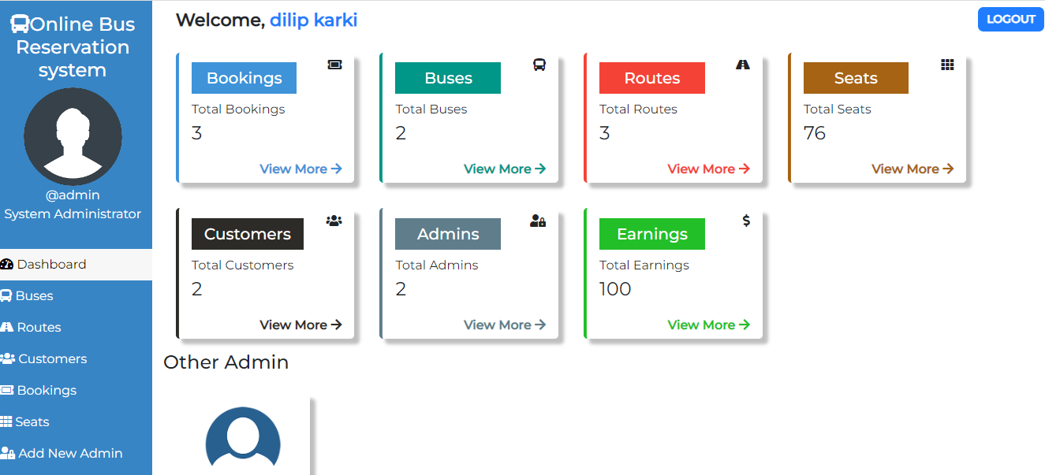

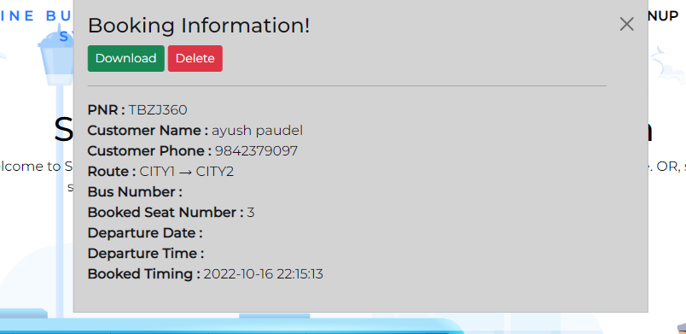

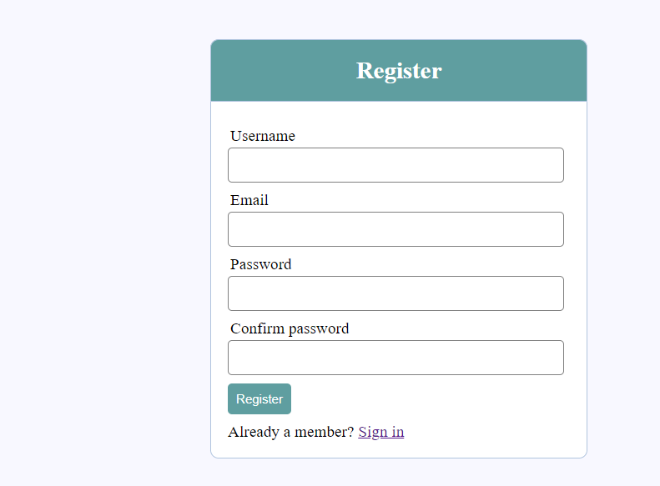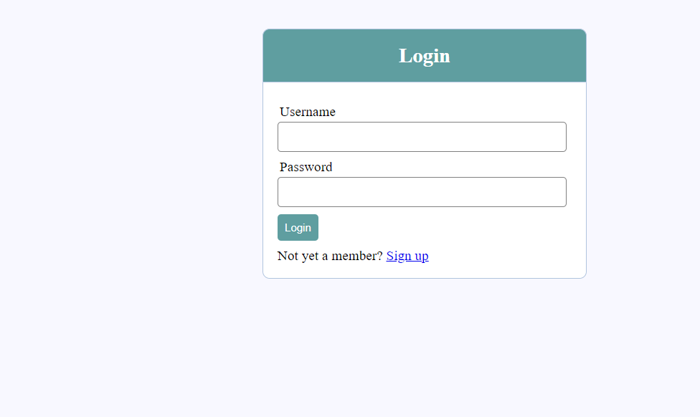

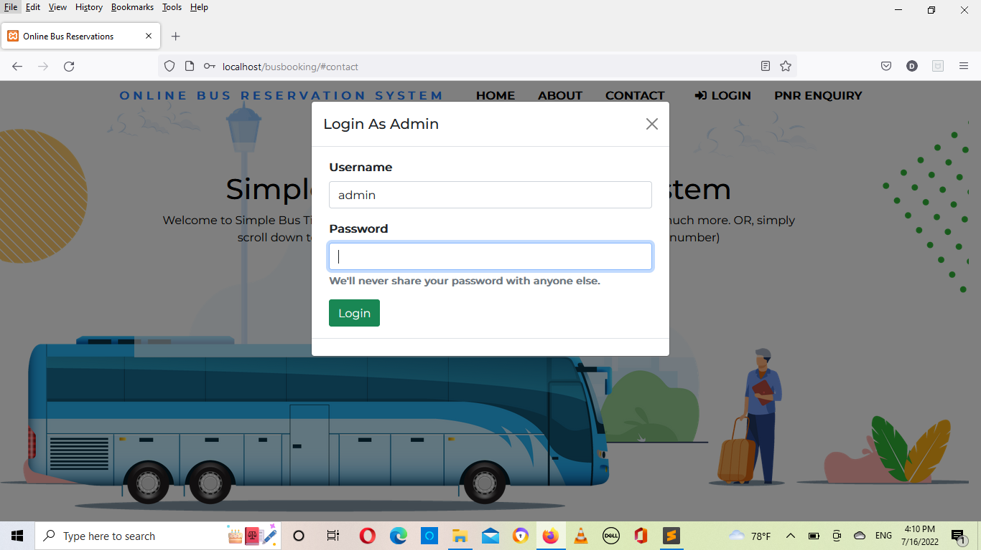

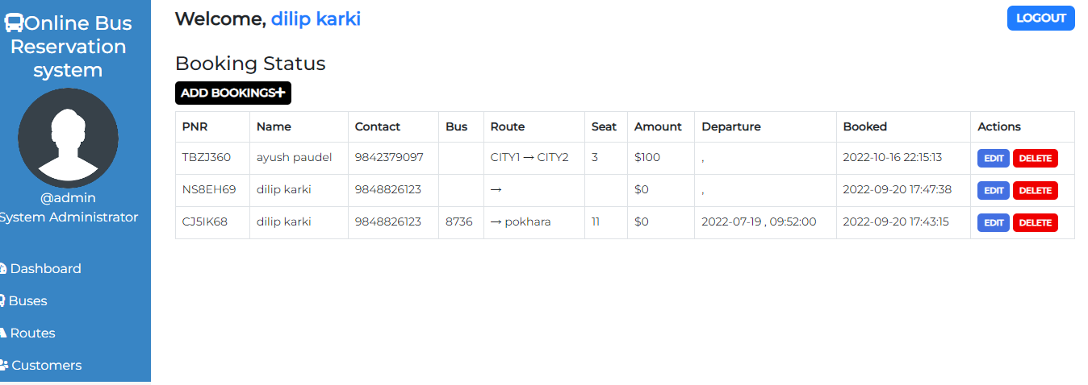

**CHAPTER 7**

**CONCLUSION**

It can be observed that computer applications are very important in every field of human endeavor. Here all the information about customer that made reservation can be gotten just by clicking a button with this new system, some of the difficulties encountered with the manual system are overcome. It will also reduce the workload of the staff, reduce the time used for making reservation at the bus terminal and also increase efficiency. This project, as a whole, will give a new way in bus reservation and ticketing process.

**CHAPTER 8**

**REFERENCES**

1. PHP database connection references retrieved from : <https://www.tutorialspoint.com/php/index.htm> (2022-06-25)
2. Bootstrap references from : <https://www.w3schools.com/bootstrap4/> (2022-06-25)
3. Images retrieved from: [www.google.com](http://www.google.com) (2022-07-03)